Bamazon: customer application instructions with pictures.

1). When you run the customer.js file, user will see the list of product ID, product name, and price.

Then it will prompt user to pick an id they would like to purchase.

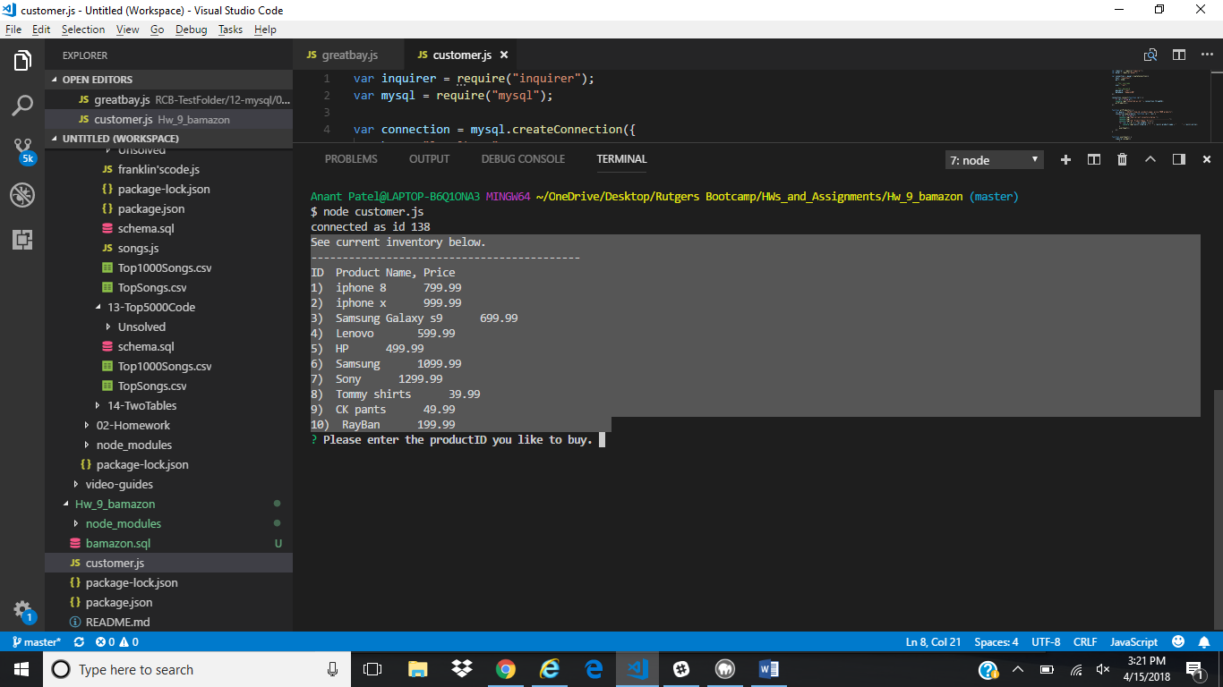

Here’s the product table.

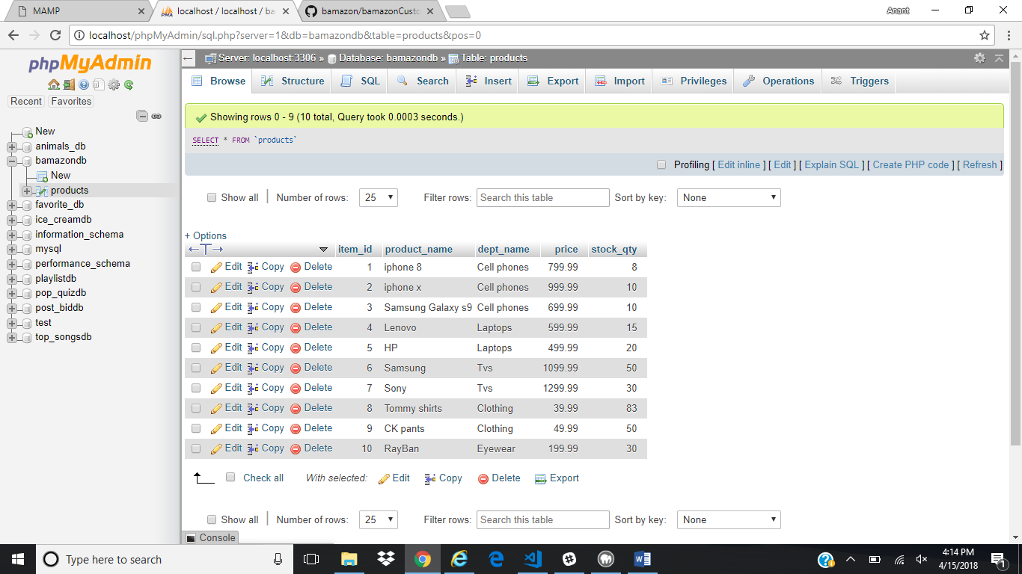

2) User enters productID: “8”, then enters qty: “1”. if qty available in stock show message saying qty available and will ask if they would like to place the order yes? Or no?

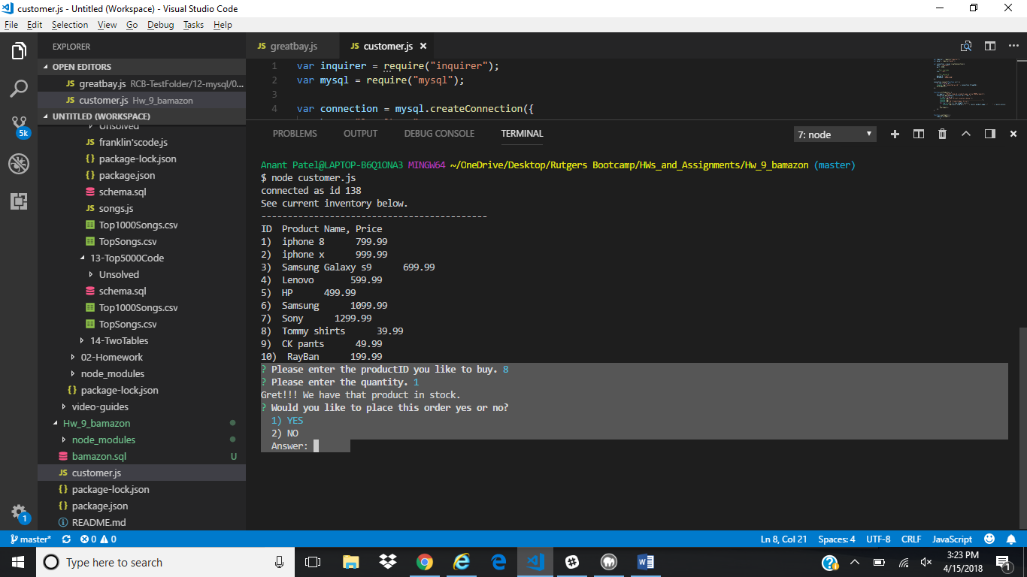

3) if the user enters “yes” then it will message congratulations your order is placed and will show the total cost of the order. AND that’s the end of the transaction for placing order.

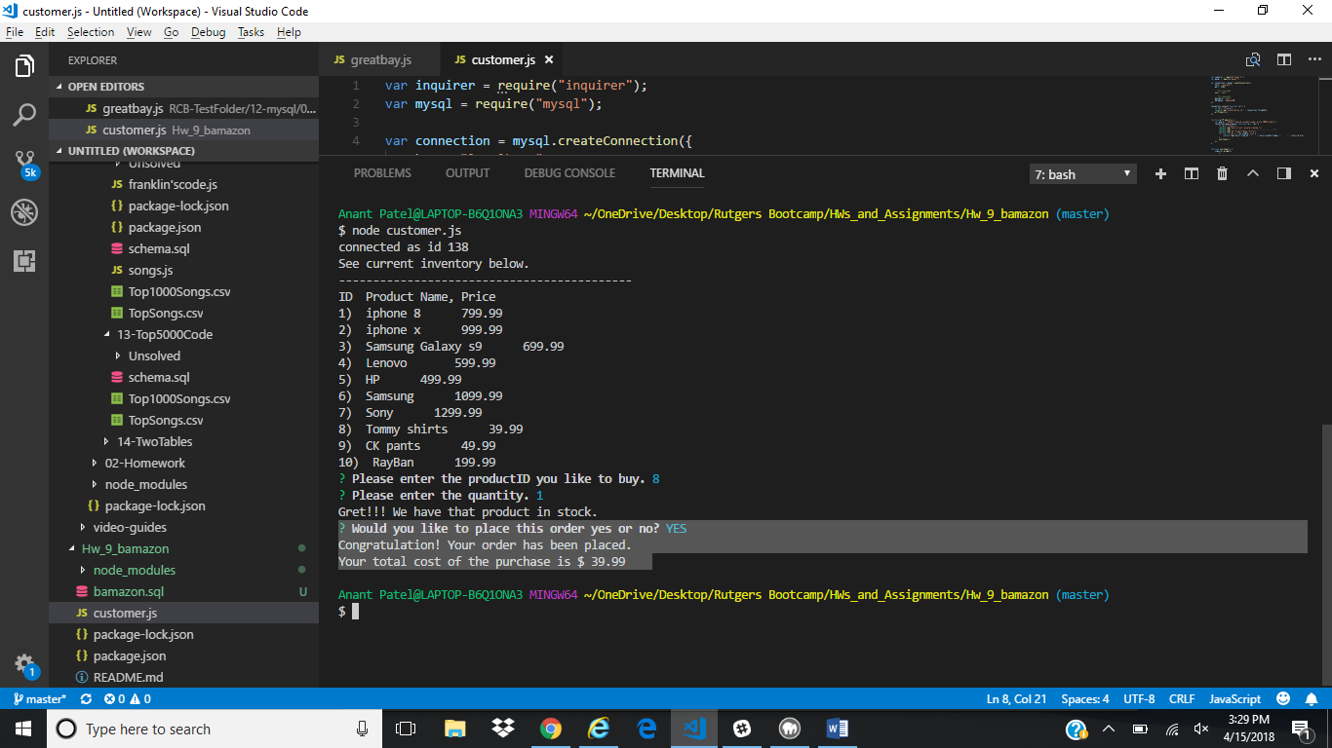

Here’s the updated SQL table item_id “8” Tommy Shirts qty changed to 82 from 83.

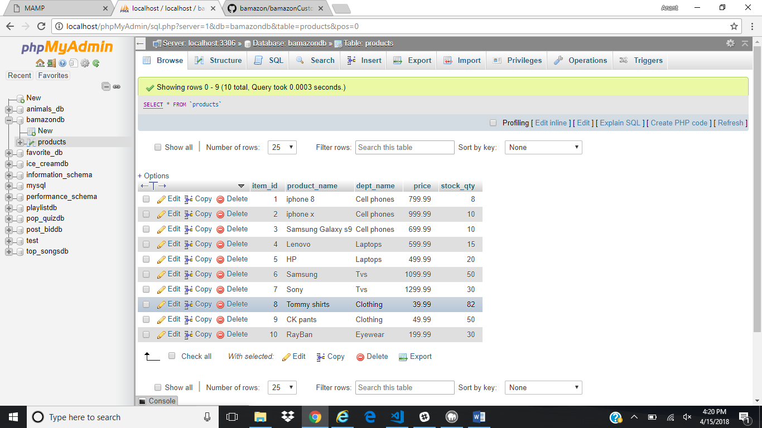

4) If requested product’s qty not available then msg “Insufficient qty” and ask user to start over or quit?

In this ex user is picking id “2” iphone X and requesting 500 qty. Available qty is only 10.

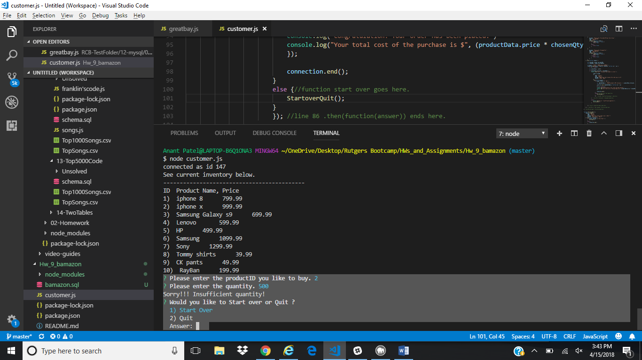

Here’s the table view where item_id “2” iphone X has only 10 qty in stock.

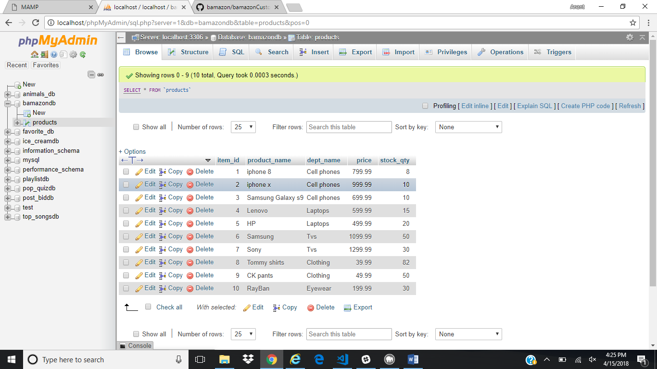

5) if user picks Quit, session ends.

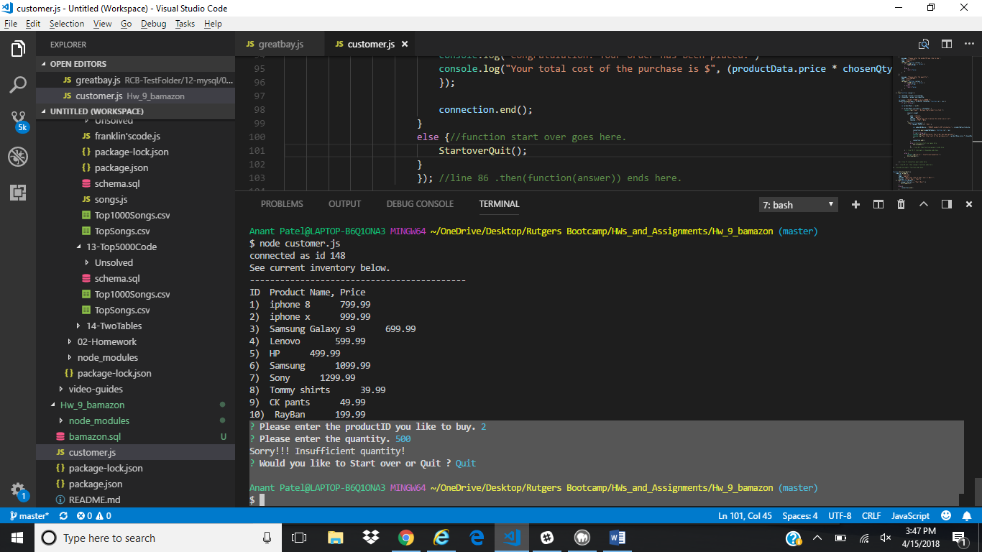

6) If user picks star over, process starts from the beginning.

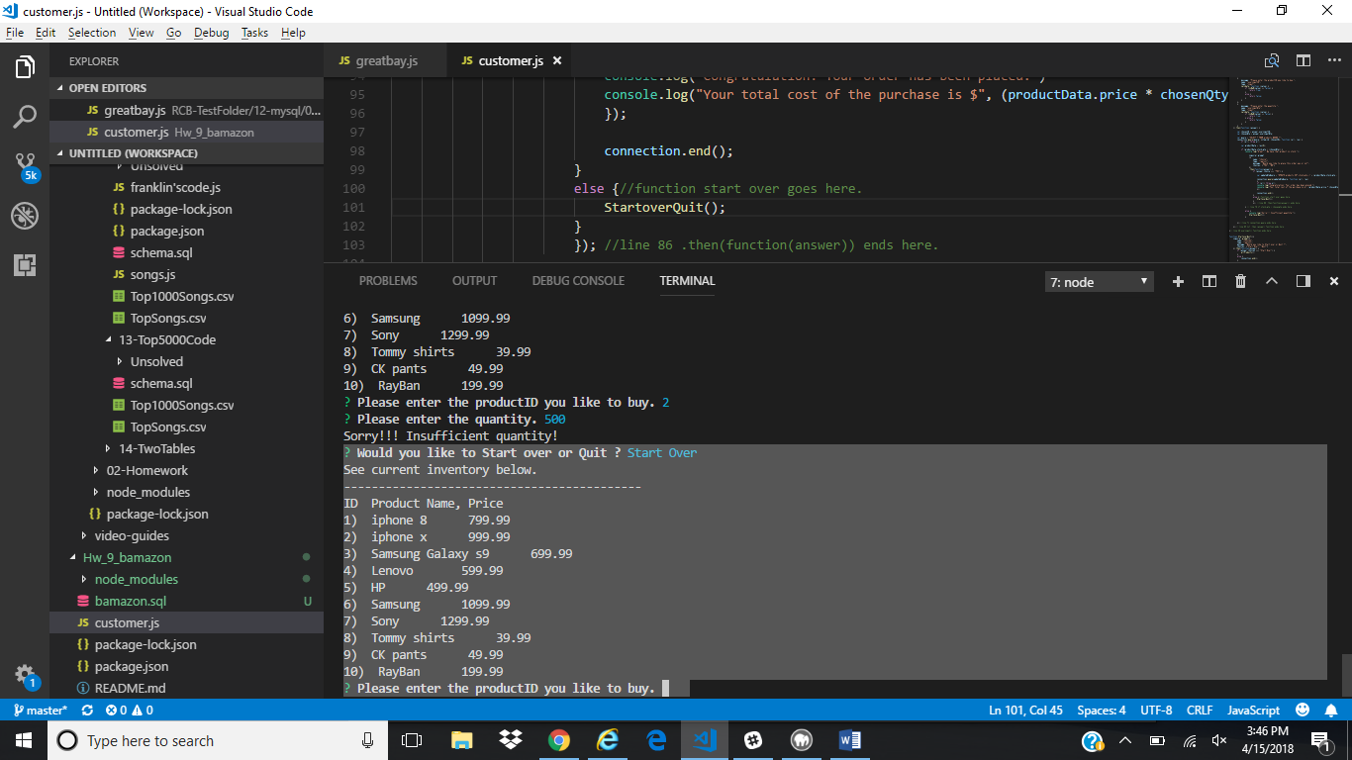

6) user can now pick another item or change the qty of their product.

In this example user picks another item id “8” and inputs qty “1”. Function then validates the qty and asks user to confirms the order.

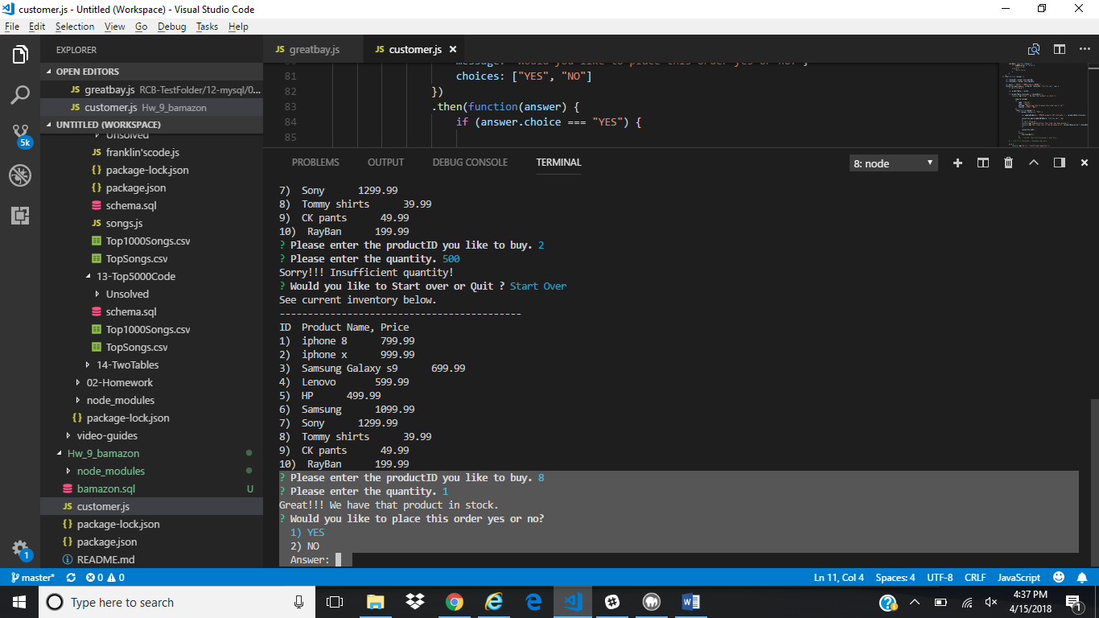

If user responds “yes” then the order goes through and shows total cost of the order and ends the transaction.

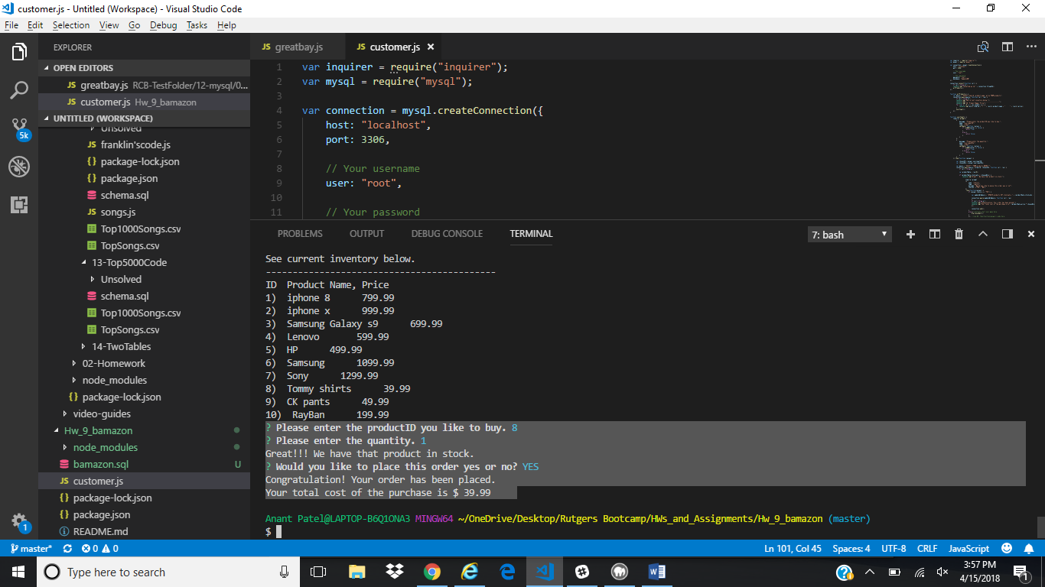

Here’s the updated SQL table item_id “8” Tommy Shirts qty changed to 81 from 82.

